- Create a ClusterIP service for an Apache web server pod.
Step 1: Create the Apache Pod
Create a YAML file named apache-pod.yaml:
apiVersion: v1
kind: Pod
metadata:
name: apache-pod
labels:
app: apache
spec:
containers:
- name: apache-container
image: httpd
ports:
- containerPort: 80
Explanation:
● app: apache label is used by the Service to identify the Pod.
● Container port 80 is the default HTTP port.
Apply the pod:
kubectl apply -f apache-pod.yaml
Verify Pod status:
kubectl get pods
kubectl get pods --show-labels
Step 2: Create the ClusterIP Service
Create a YAML file named apache-clusterip.yaml:
apiVersion: v1
kind: Service
metadata:
name: apache-clusterip
spec:
type: ClusterIP
selector:
app: apache
ports:
- port: 80
targetPort: 80
Explanation:
●ClusterIP type exposes the service internally.
●selector ensures traffic is routed to the Apache pod(s).
●port is the port for other pods to use to access the service.
●targetPort is the actual port on the container.
Apply the service:
kubectl apply -f apache-clusterip.yaml
Verify Service:
kubectl get svc
kubectl describe svc apache-clusterip
Check that Endpoints shows the Pod IP:
Endpoints: 10.x.x.x:80
This means the service is successfully routing traffic to the Pod.
Step 3: Test the Service Internally
You cannot access ClusterIP directly from your laptop/browser. Use a temporary Pod inside the cluster:
kubectl run test-client --image=busybox:1.28 -it --rm --restart=Never -- sh
Inside the BusyBox shell, run:
wget -qO- <apache-clusterip>
You should see:
<html><body><h1>It works!</h1></body></html>
Exit the shell:
Exit
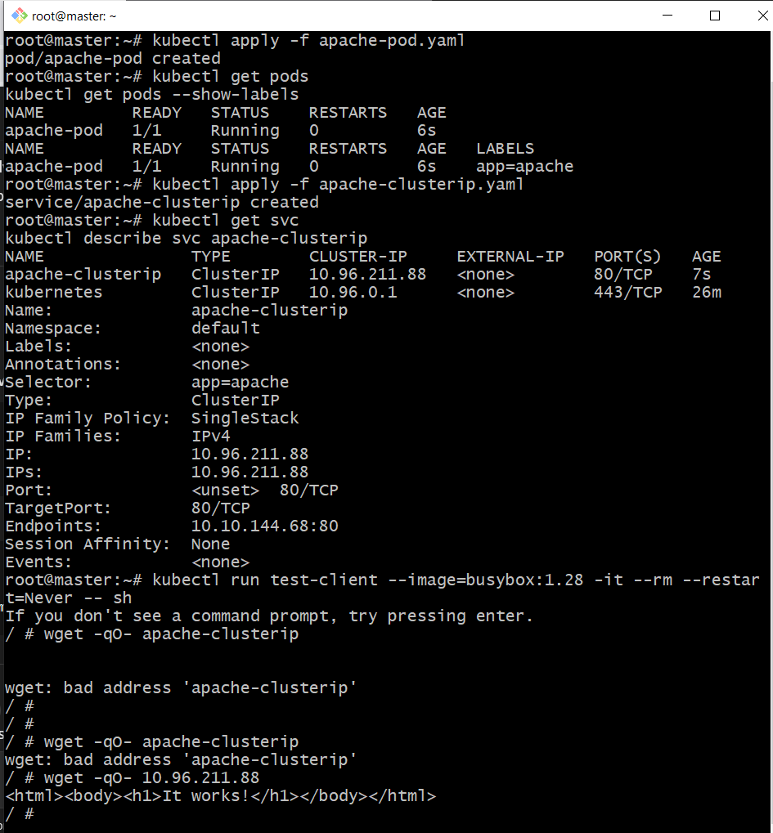
- Expose an Nginx pod externally using a NodePort service.
vi nginx-pod.yaml
apiVersion: v1
kind: Pod
metadata:
name: nginx-pod
labels:
app: nginx
spec:
containers:
- name: nginx
image: nginx
ports:
- containerPort: 80

vi nginx-nodeport.yaml
apiVersion: v1
kind: Service
metadata:
name: nginx-nodeport
spec:
type: NodePort
selector:
app: nginx
ports:
- port: 80
targetPort: 80
nodePort: 32080 # optional; must be between 30000-32767
Open NodePort in AWS Security Group
● Go to EC2 → Security Groups → Inbound Rules
● Add a rule:
○ Type: Custom TCP
○ Port Range: 32080
○ Source: your IP (or 0.0.0.0/0 for testing)
kubectl apply -f nginx-pod.yaml
kubectl apply -f nginx-nodeport.yaml
kubectl get svc nginx-nodeport
curl http://<node-ip>:32080
kubectl get nodes -o wide
kubectl get pods -o wide -l app=nginx
curl 172.31.20.112:32080
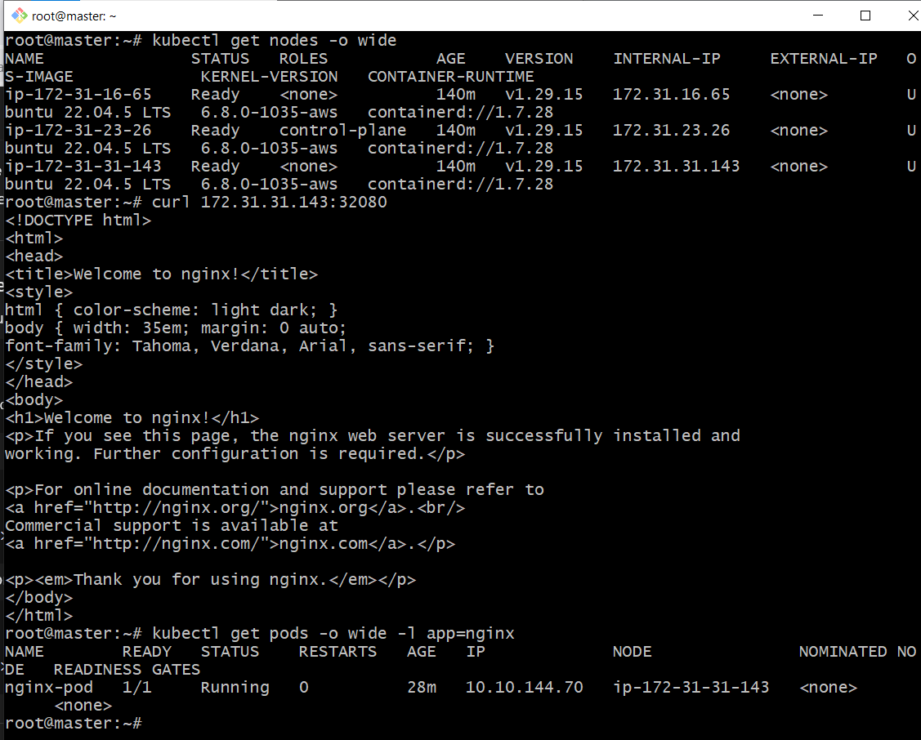
Nginx running on Worker2
http://<publicip>:32080/
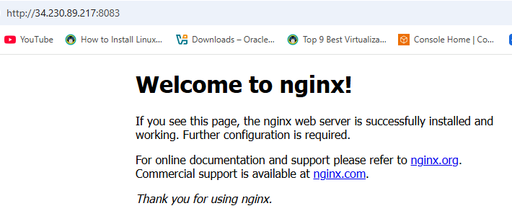
- Deploy a ReplicationController to maintain 3 replicas of an Nginx pod.
vi nginx-rc.yaml
apiVersion: v1
kind: ReplicationController
metadata:
name: nginx-rc
spec:
replicas: 3
selector:
app: nginx
template:
metadata:
labels:
app: nginx
spec:
containers:
- name: nginx
image: nginx
ports:
- containerPort: 80
kubectl apply -f nginx-rc.yaml
kubectl get rc
kubectl get pods -l app=nginx
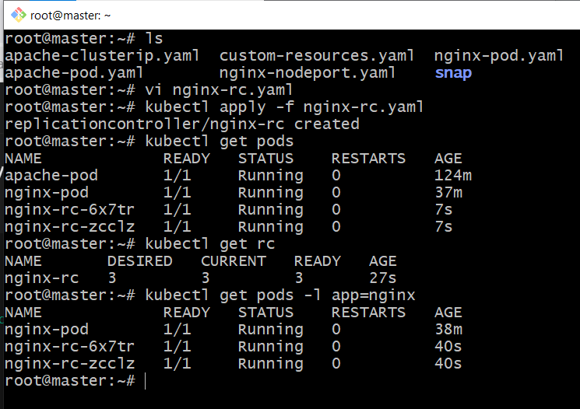
- Scale the ReplicationController from 3 replicas to 5 replicas.
kubectl scale rc nginx-rc --replicas=5
kubectl get rc
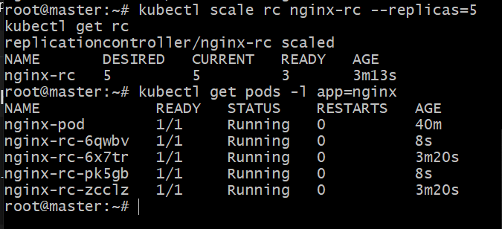
- Create a ReplicaSet to manage pods based on multiple labels (prod and test).
vi multilabel-rs.yaml
apiVersion: apps/v1
kind: ReplicaSet
metadata:
name: nginx-multilabel-rs
spec:
replicas: 3
selector:
matchLabels:
env: prod
tier: test
template:
metadata:
labels:
env: prod
tier: test
spec:
containers:
- name: nginx
image: nginx

kubectl apply -f multilabel-rs.yaml
kubectl get rs
kubectl get pods -l env=prod,tier=test
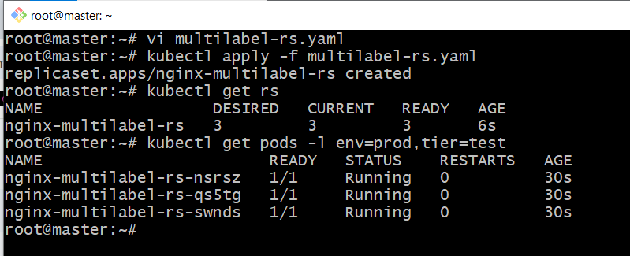
- Deploy a ReplicaSet that excludes pods with the label backend.
vi exclude-backend-rs.yaml
apiVersion: apps/v1
kind: ReplicaSet
metadata:
name: exclude-backend-rs
spec:
replicas: 2
selector:
matchExpressions:
- key: role
operator: NotIn
values:
- backend
template:
metadata:
labels:
role: frontend # Pod label that is NOT 'backend'
spec:
containers:
- name: nginx
image: nginx
ports:
- containerPort: 80

Explanation:
Field Purpose
replicas: 2 Number of pods this ReplicaSet will maintain
matchExpressions Selector excludes pods where role=backend
labels The pods created by this ReplicaSet get role=frontend
containerPort: 80 Nginx default HTTP port
This ensures pods labeled backend are never managed by this ReplicaSet.

Apply the ReplicaSet
kubectl apply -f exclude-backend-rs.yaml

Check that the ReplicaSet is created and pods are running:
kubectl get rs
kubectl get pods -l role=frontend
kubectl get pods --show-labels
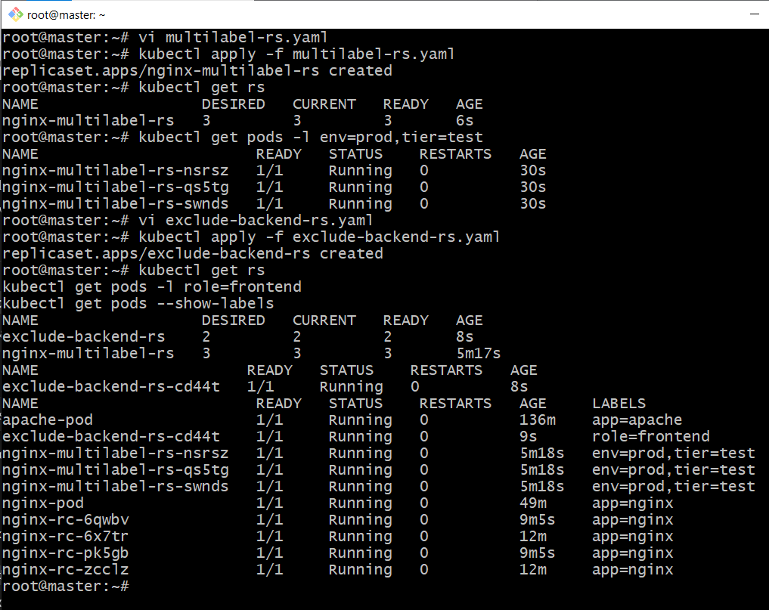
Verify Exclusion of backend Pods
1. Create a dummy pod labeled role=backend (optional for testing):
kubectl run backend-test --image=nginx --labels="role=backend"
Check that ReplicaSet does not manage it:
kubectl describe rs exclude-backend-rs
● The Endpoints or Pods section should only show role=frontend pods.
● The backend-test pod remains untouched.
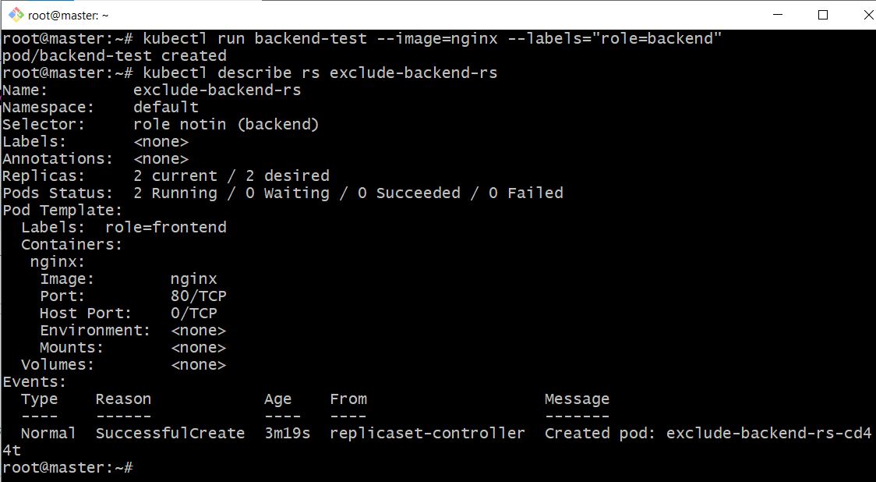
- Test load balancing across multiple pods using a Node Port service.
vi nginx-loadbalance.yaml
apiVersion: v1
kind: Service
metadata:
name: nginx-loadbalance
spec:
type: NodePort
selector:
app: nginx
ports:
- port: 80
targetPort: 80
nodePort: 32081
Test
kubectl apply -f nginx-loadbalance.yaml
kubectl get svc nginx-loadbalance
Now test multiple times:
curl http://<node-ip>:32081
You should see responses from different pod IPs when Nginx access logs are checked:
kubectl logs <pod-name> -f
Which pods are load-balanced?
Your service selector is app=nginx, so all pods with that label will receive traffic.
Check:
kubectl get pods -l app=nginx -o wide
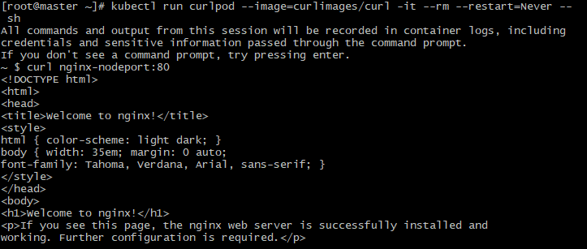
Test internally (cluster)
From master node:
curl <Any-worker-private-ip>:32081
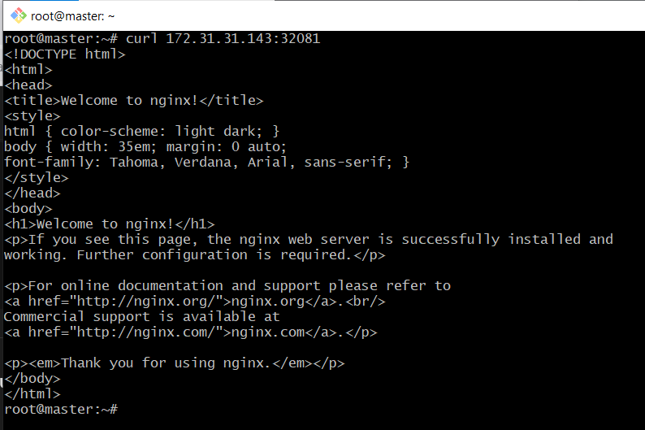
- Delete a Replication Controller without affecting the running pods.
1. Delete the RC but keep pods running
kubectl delete rc test-rc --cascade=orphan
2. Check that pods are still running
kubectl get pods -l app=nginx-test

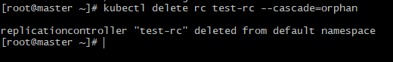
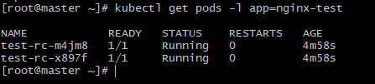
The pods should continue running even after the RC is deleted.

